Objective: Combined “Beta Score” that takes a couple of markers and use them in a multivariate combination to improve sensitivity and specificity.

The goal was to understand whether measuring the percentage of unmethylated insulin cfDNA combined in a model with other marks could help better identify individuals at higher risk of developing diabetes. I wanted to see how well this single marker of %unmeth performs compared to a multivariable “Beta Score” that also takes into account A1c, age, and BMI. Since some patient records were missing values, we also tested a method called multiple imputation (MICE) so that we could make use of all 57 patients in the dataset rather than only the smaller subset with complete data, but needs to be interpreted with nuance until we get more data to support the data models.
Summary of findings

1. Original %Unmethylated only marker
Worked well, with an optimal cutoff around 10% unmethylated, but limited in predictive power when used alone.
2. Beta Score (combination of A1c, Age, BMI and %unmeth)
The problem here is that not all the patients had A1c scores (only 26 of them) and also that we can’t include insulin and C-peptide since we cannot confirm fasting state.
Combining %Unmethylated, A1c, age, and BMI gave perfect separation (AUC = 1.0) in the small subset with complete data (n=26).
This looks impressive, but it’s likely inflated because the dataset was small and very cleanly separated.
However, it proves that this warrants a valid approach.
3. Beta Score with MICE (using imputation to give 57 complete cases)
MICE is a statistical method of imputation (predicting numbers to fill gaps). Fortunately there are R-Studio and Python scripts for this which makes it relatively easy, albeit being left blinded to the math.
Performance remained very strong (AUC ≈ 0.98) but more realistic than the “perfect” result seen in item 2 above.
The optimal cutoff for classifying patients was around 0.48 probability cutoff, with a high balance of sensitivity and specificity.
This version is more representative and is the preferred framework for moving forward.
This should not be considered fact due to MICE, but proves that point that combination of multivariate data points can yield a better score

Model | N used | AUC | Optimal cutoff | Youden | Sensitivity | Specificity | PPV | NPV | Accuracy | Optimal cutoff (prob)
Original: Unmethylated only | 57 | 0.904 | 9.98 | 0.723 | 0.87 | 0.853 | 0.8 | 0.906 | 0.86
Beta Score (no imputation) | 26 | 1.0 | - | 1.0 | 1.0 | 1.0 | 1.0 | 1.0 | 1.0 | 0.453
Beta Score (MICE pooled) | 57 | 0.98 | - | 0.854 | 0.913 | 0.941 | 0.913 | 0.941 | 0.93 | 0.486

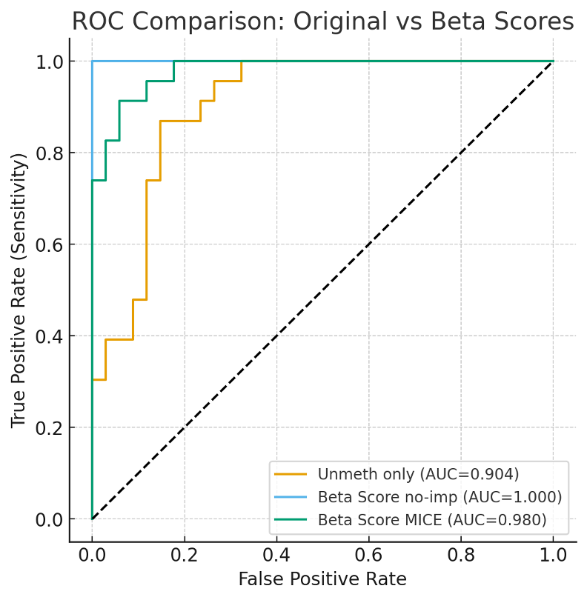

Yellow = original (only % unemthyalted) - current
Blue = 26 samples (A1c, BMI, age, %unmeth) - unrealistic
Green = 56 samples with MICE (A1c, BMI, age, %unmeth) - imitates potential reality of a large N

Takeaways
Multivariable is better. Using a composite Beta Score outperforms relying on %Unmethylated alone, especially once you add A1c, age, and BMI. We saw an increase in in sensitivity from 87% to 91.3%, specificity from 85% to 94%, and PPV from 80% to 91% by using this model.
Beware small sample bias. The perfect performance seen in the 26 complete cases is misleading since models trained on small subsets may overfit.

Next steps
Validate the Beta Score in a larger, independent cohort.
Refine cutoff thresholds as more borderline cases are added.
Explore whether additional clinical factors (blood pressure, family history, etc.) further improve the score.
Begin defining risk bands (low / intermediate / high) for practical use in clinical decision-making.

